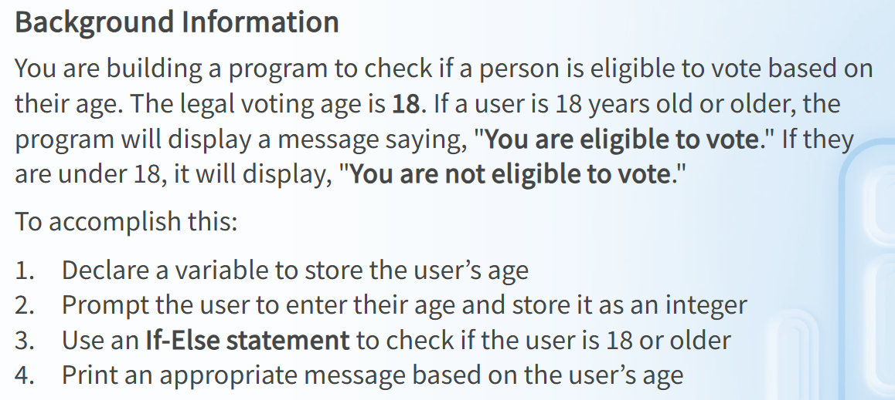
int age;
Console.WriteLine(“Enter your age: “);

age = int.Parse(Console.ReadLine());

if (age >= 50)

{
Console.WriteLine(“You are eligible to vote.”);
}

else

{
Console.WriteLine(“You are not eligible to vote.”);
}

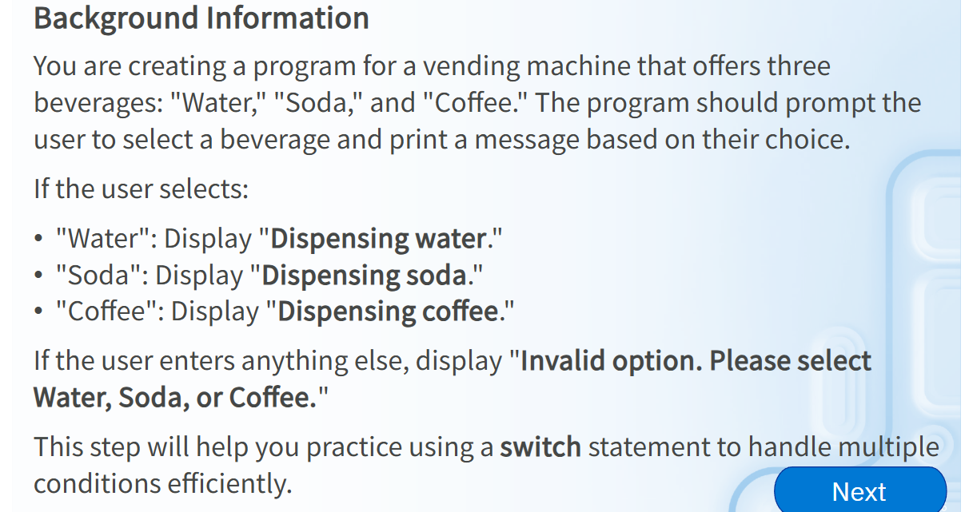

string choice;
Console.WriteLine("Select a beverage: Water, Soda, Coffee.");
choice = Console.ReadLine();
switch (choice)
{
case "Water":
Console.WriteLine("Dispensing water.");
break;
case "Soda":
Console.WriteLine("Dispensing soda.");
break;
case "Coffee":
Console.WriteLine("Dispensing coffee.");
break;
default:
Console.WriteLine("Invalid option. Please select Soda, Water, or Coffee.");
break;
}

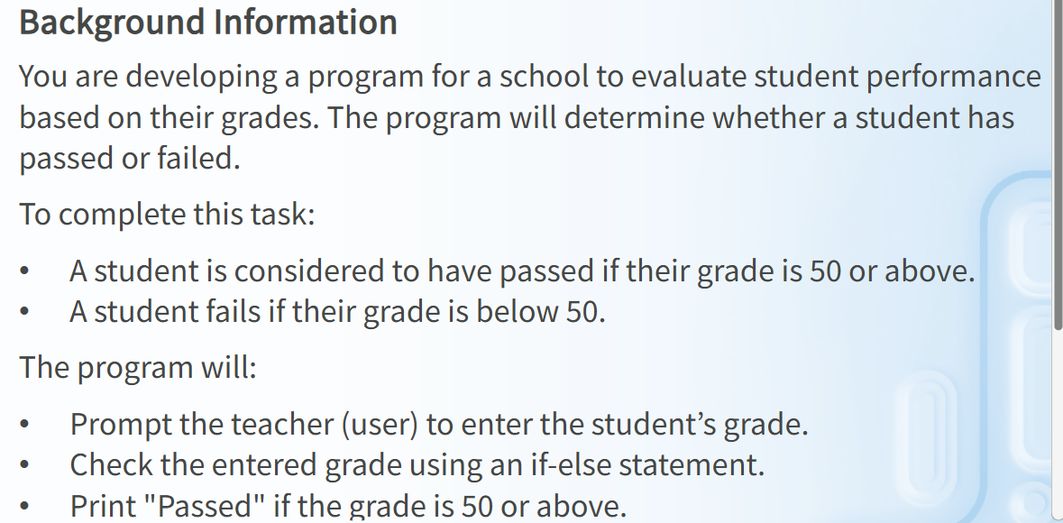
int grade;
Console.WriteLine("Enter student's grade:");
grade = int.Parse(Console.ReadLine());
if (grade >= 50)
{
Console.WriteLine("Passed.");
}
else
{
Console.WriteLine("Failed");
}

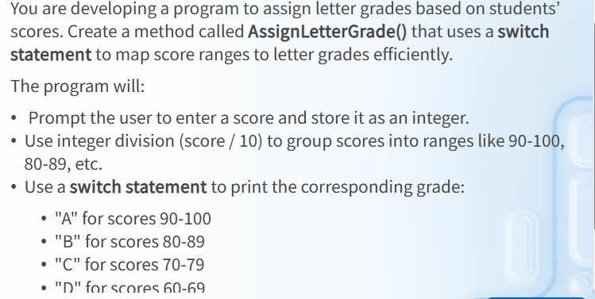

int score;
Console.WriteLine("Enter student's score:");
score = int.Parse(Console.ReadLine());
switch (score / 10)
{
case 10:
case 9:
Console.WriteLine("A");
break;
case 8:
Console.WriteLine("B");
break;
case 7:
Console.WriteLine("C");
break;
case 6:
Console.WriteLine("D");
break;
default:
Console.WriteLine("F");
break;
}

